EENG 385 - Electronic Devices and Circuits

Lab 6 – Audio Board Buildup

Lab Handout

# Objective

The objective of this lab is to study the design and layout of the audio board and then to complete the assembly.

# Voltage Regulators

You will supply the main power input to the Audio board with 9V, supplied by a 110 VAC/ 9V DC wall converter or from the lab power supplies. This 9V is then converted to 5V or 2.5V for the op amp circuit.

The main 9V power input is sent, unregulated, to the power amplifier that drives the speaker. Unregulated means that whatever voltage you provide to the board is passed directly onto the power amplifier. There are reasons that you may want to do this and the board should be fine up to 30V. Above this you will be driving some of the components beyond their maximum rated voltages and run the risk of overheating the power amplifier. Proceed down this path incrementally and with caution.

Now, back to the 5V and 2.5V. These two voltages are supplied to the Audio board using voltage regulators. A voltage regulator is a circuit element that supplies a constant voltage to a load independent of the input voltage and the load’s current requirements. As a practical matter, all voltage regulators have limits to the range of input voltages and load currents that they can handle.

**LM7805**

Before diving into the details of the LM7805, let’s take a minute to talk about how it works. The LM7805 is a linear regulator. The input voltage to the linear regulator is always higher than the voltage supplied to the load. Linear regulators are not power efficient; you will never see one in a cell phone or laptop. This is because linear regulators dissipate a power equal to the difference between the input and output voltages times the current being supplied to the load. So, for example, if the input voltage to a linear regulator is 9V, the output voltage 5V, and 250mA of current is being supplied to the load, the linear regulator will dissipate (9V – 5V)*0.25A = 1 Watts of power. Yikes, that is going to make the regulator very hot and unsafe to touch!

# In the pantheon of linear regulators, one family stands above the rest, the LM78xx. The “xx” in the family name is a numerical code of the output voltage. We are using the 7805 in our design, so the linear regulator will output 5V.

# Let’s learn about the capabilities of this jellybean component by examining its technical documents.

* Open the Bill of Materials for the Audio board found on the Canvas page for this lab
* Find the row for the 7805, It’s a linear voltage regulator and locate the Digikey part number. Note, all Digikey part numbers end with “-ND”.
* Open the Digitkey.com web site and search for the part number you just found.
* On the resulting part page, open the PDF datasheet.

Use the information on the datasheet to answer the following questions. When referencing a figure in the technical documents, I will use the notation “TD-Figure” as opposed to references to figures in this document which are notated “Figure”.

1. What two things make the L7805 essentially indestructible?
2. Use TD-Figure 2 to name each of the 3 pins below. For example, A = GND, B = GND, C=GND. Clearly, this is not the correct answer.

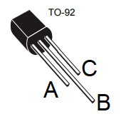

1. Look at TD-Table 1, what is the absolute maximum input voltage for our regulator?
2. Look at TD-Table 1, what is the absolute maximum output current for our regulator?
3. The minimum difference between the input voltage and the output voltage is called the dropout voltage. Find the TD-Table for the Electrical characteristics for our linear regulator. What is the dropout voltage?

**Zener Diode Regulator**

The 2.5V regulated voltage source (half of the 5V supply) for two op amp inputs. Since this supply does not need to deliver much power the design uses one of the lowest cost options for a voltage regulator, a Zener diode.

When an increasing reversed biased (meaning its cathode potential is higher than its anode) voltage is applied to the Zener diode, it reaches its breakdown voltage, where it starts allowing large amount of electric current to flow. There are an almost unlimited variety of different breakdown voltages to choose from. We are using a Zener diode with a 2.5V breakdown voltage configured as shown in Figure 1.

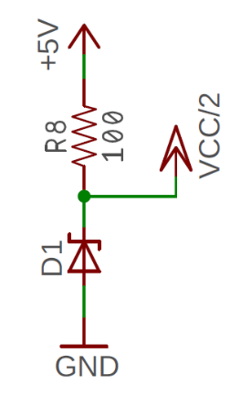

Figure 1: A Zener diode-based regulator.

# Let’s learn about the capabilities of this jellybean component by examining its technical documents.

* Open the Bill of Materials for the Audio board found on the Canvas page for this lab
* Find the row for the Zener diode and locate its Digikey part number.
* Open the Digitkey.com web site and search for the part number you just found.
* On the resulting part page, open the PDF datasheet.

Use the information on the datasheet to answer the following questions. When referencing a figure in the technical documents, I will use the notation “TD-Figure” as opposed to references to figures in this document which are notated “Figure”.

1. What two marking will you always see on a device package?
2. The power dissipated in a Zener diode is the breakdown voltage (the voltage drop across it) times the current. What is the power dissipated by the Zener diode on our board (shown in Figure 1)? Represent your answer in milliwatts.
3. What is the maximum power that can be dissipated by the Zener Diode?

**Power-on LED**

A power-on LED shown in Figure 2 provides positive confirmation that power is bring delivered to the circuit. This is a “must-add” to any PCB you are designing and will save you many hours of head-scratching wondering diagnosing malfunctions which are the result of no power being supplied to your circuit.

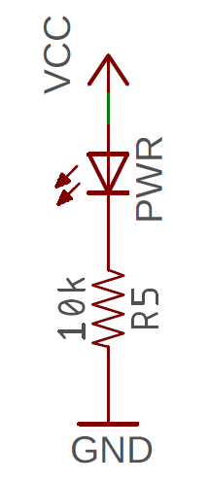

Figure : The power-on LED uses a current limiting resistor to set the LEDs brightness.

When considered as a circuit element, an LED is first and foremost a diode. This means that current flows from the anode to the cathode while dropping voltage. The brightness of the light emitted from an LED is proportional to the current flowing through the LED. The wavelength of the light emitted from an LED is roughly inversely proportional to the forward voltage drop. For example, long wavelength colors like red (680nm) have low voltage drops (1.7V), while shorter wavelength colors like blue (450nm) have higher voltage drops (3.7V).

The resistor in series with the LED limits the current flowing through the LED. Let’s work through the following questions to understand how to choose the value for this resistor. Start by pulling the technical documents for our LED by using its Digikey part number from the BOM.

1. What is the maximum continuous current that you can send through the LED?
2. What is the dominate wavelength of the light emitted by our LED?
3. What is the typical forward voltage drop of the LED when 20mA is flowing through the LED?
4. Assuming that VCC = 9V, what is the voltage drop across the current limiting resistor R5 in Figure 2?
5. Assuming that VCC = 9V, how much current flows through the current limiting resistor R5 in Figure 2?
6. Check the Forward Current vs. Forward Voltage graph in the technical document. Is the voltage drop across the LED at this (low) current is close to the voltage drop given in question 3?
7. Given the circuit configuration shown in Figure 2, what is the maximum VCC you can supply without exceeding the maximum continuous current through the LED?
8. Given the circuit configuration shown in Figure 2 with VCC=9V, what is the smallest resistance you can use for R5 without exceeding the maximum continuous current through the LED?
9. What resistance of R5 would you choose if you wanted 5mA to flow through the LED with VCC=9V?

**On/Off switch**

There are few electrical components simpler than an on/off switch. Yet, if you are not careful, you can make silly mistakes that can result in your silk screen being backwards and confusing your students. Let’s look at switches so that you can avoid such embarrassing mistakes.

Switches are characterized by the number of throws and the number of poles. Throws refers to the number of positions that you can place the switch in. Our on/off switch has two positions (left and right), so it is called a double throw. A more sophisticated rotary switch may have as many as 10 positions making it a 10-throw switch. Poles refers to the number of parallel switches moved with the single switch actuator. Our on/off switch actuates one circuit, so it is a single pole. A switch that could turn on two circuits (like a light and a motor), is called a double pole. From this explanation, I hope that it is clear that our on/off switch is a Single Pole, Double Throw (SPDT) switch.

Almost every SPDT slide switch I have ever worked with has a conductive slide that is moved between pairs of terminals like the slide switch shown in Figure 3. Moving the actuator to the left/right connects the center pin to the left/right pin respectively. The center pin is often called the common pin because it is common with either actuator position. Rocker switches have internal mechanical pivot which cause the actuator to connect the pair of pins opposite the actuators position. Again, the center pin of a rocker switch is called the common pin because it is in common with either actuator position.

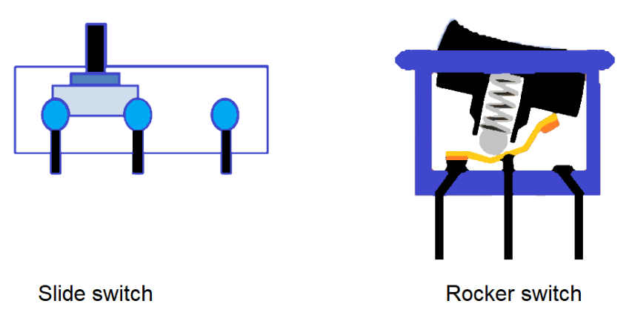

Figure : Two common types of SPDT switches.

Let’s dive into the technical documents to see how these concepts are conveyed in manufactured datasheets. Start by pulling the technical documents for the slide switch used for the BJT curve tracer and the Audio board by finding their Digikey part number in their respective BOMs.

1. Using the BOM for the Audio board, what is the manufacture part number for the slide switch? Use this part number to locate the correct switch in the E-Switch technical document.
2. Which of the following (A or B) is being used for the Audio board PCB?

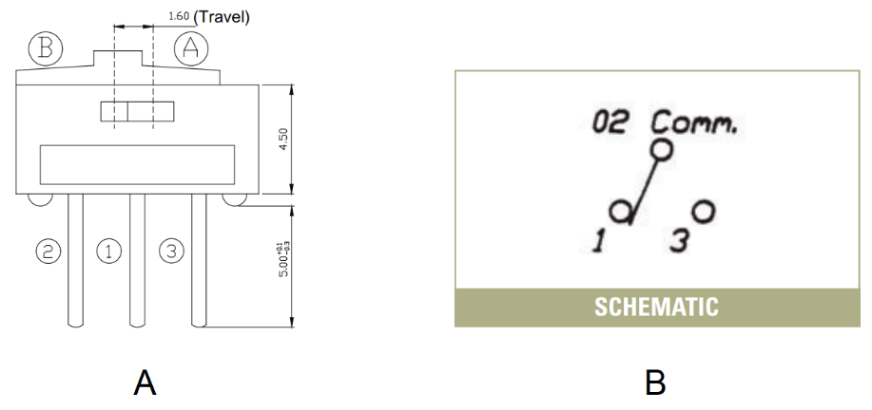

Figure : Switch operation as defined in the manufacture’s technical documents.

1. What is the maximum voltage and current that can be handled by the BJT curve tracer switch? Use the information posted on the Digikey parts page for this switch, do not use the technical documents.
2. What is the maximum voltage and current that can be handled by the Audio board switch? Use the information posted on the Digikey parts page for this switch, , do not use the technical documents.
3. In Figure 4A, what pair of terminals are connected when the actuator is in position B?
4. Do the manufacture technical documents for the switch in Figure 4B, make it clear what pair of terminals are connected together when the actuator is in its left position?

Now, let’s move on to the details of assembling your Audio board.

**Soldering Together the Audio Board**

We will start this set of labs on the Audio board by first building it then performing experiments in the following weeks. The Audio board has far fewer resistors than the BJT curve tracer. Even so, it’s worth your time to brush-up on how to interpret the resistors color bands of the resistors that you will use in this lab.

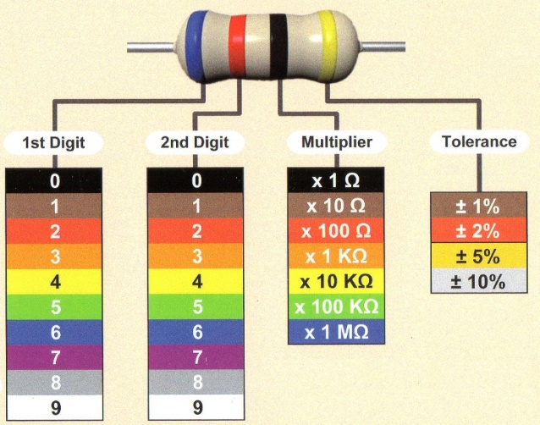

Figure : The colored bands on resistors encode its resistance.

Use the handy table in Figure 5 to complete the blank space in Table 1 with the color or resistance code.

Table : Complete the missing entries in the table of resistance color codes.

|  |  |  |  |  |
| --- | --- | --- | --- | --- |
| Value | Band 1 | Band 2 | Band 3 | Band 4 |
| 100 |  |  |  | Gold |
| 1k |  |  | Red | Gold |
|  | Red | Red | Red | Gold |
|  | Brown | Black | Orange | Gold |
| 100k |  |  |  | Gold |

# You will be soldering the complete Audio board this week. The schematic is shown in Figure 6. On a philosophical note, the schematic shows the logical relationship between parts in a familiar format. When I design a schematic, I try to isolate function units of the design. I then connect these functional units together using named wires. These named wires greatly reduce the wiring clutter on the schematic and make the schematic more readable.

# One note about my design that may cause some confusion; I added an optional diode to the design in case 2 diodes in series provided insufficient voltage drop across the base of the NPN and PNP power transistors. Having built the board, I have verified that 2 diodes are sufficient. This means that you will not populate the optional diode D2. Take a moment and locate diode D2 on the schematic – we will come back to this later.

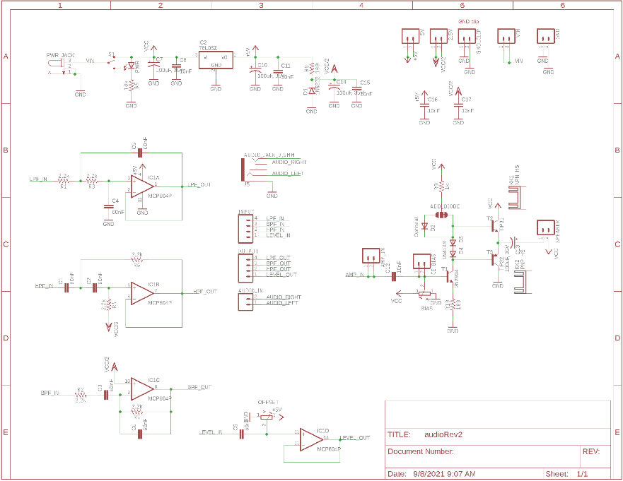

Figure : The schematic for the Audio board.

Like, your previous experiences, the parts in this schematic have a designator and a value. These designators are used to relate a part in the schematic with layout. I converted the schematic in Figure 6 to the layout shown in Figure 7. As before, the physical position of the parts in the schematic and layout are unrelated, the schematic is an abstraction of the finished layout. The layout contains all the data used in the fabrication of the PCBs – the layout and the fabricated PCB are identical.

**Error:** I made a small error in the design of the PCB that will cause confusion if you do not read the following. The white text on the PCB is called silk screen and provides documentation to the assembler and user of the PCB (you). I mistakenly labeled diode D3 “optional”. In fact, as discussed previously, diode D2 is the optional diode.  **You should populate diode D3 with a 1N4148 signal diode and leave diode D2 empty.**

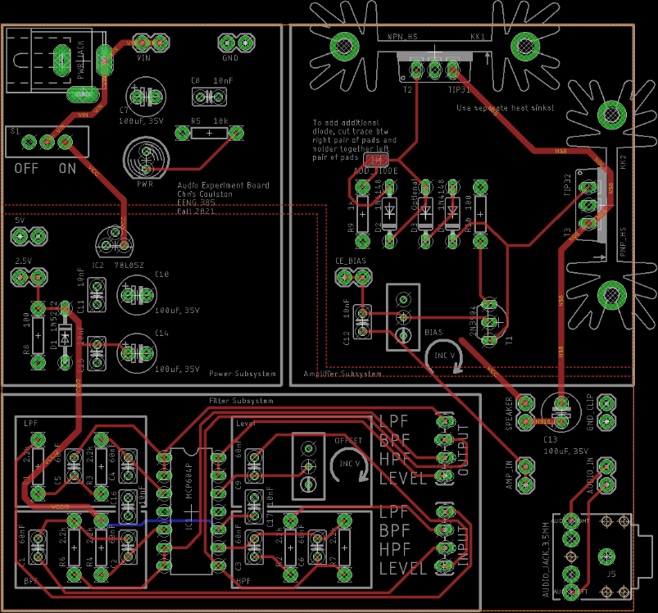

Figure : The layout of the BJT curve tracer.

You should notice that parts logically related in the schematic are physically proximal in the layout.

# Polarized parts

Most of the parts that you will solder into the PCB can be installed in more than one way. Parts which must be installed in a correct orientation are called polarized. Polarized parts have some physical indication of their orientation and the silk screen will have some marking to show you where this physical indicator should be aligned. Let’s walk through all the polarized parts and how you will install them in the PCB.

* Potentiometers

While potentiometers are not strictly polarized, you can install them either way and they will work properly, if you install them backwards, the silkscreen will not align to their function indicated on the silk screen. So make sure to align the metal screw on the pot over the circle on the silk screen.

* Zener Diode 1N5222

The Zener diode are orange with a black stripe on one end and marked with “22”. The black strip needs to align with the white stripe on the PCB silk screen.

* Signal Diodes 1N4148

The signal diodes are orange with a black stripe on one end and marked with “41 - 48”. The black strip needs to align with the white stripe on the PCB silk screen. Note, you only need to install diodes D3 and D4. You should not install the optional diode D2.

* Op amp

The op amp and IC socket have a u-shaped indentation which indicates the top. This U-shaped indentation should align with the U-shaped contour on the PCB silk screen.

* Red 100uF capacitors

The 100uF capacitors have a white stripe which indicates the negative terminal. The negative terminal should align with the white bar (opposite the “+” bar) on the PCB silk screen.

* TIP31 and TIP32 transistors

The TIP31 and TIP32 transistors are in TO-220 packages with metal tabs on the back. These metal tabs should face the edge of the board.

* 2N3904 transistor

The 2N3904 transistor is in a small TO-92 package - the package is marked “2N3904”. Make sure that its flat side matches the silk screen.

* LM7805 voltage regulator.

The LM7805 voltage regulator is in a small TO-92 package. The package is marked “L78L05”. Make sure that its flat side matches the silk screen.

* Green LED

The green LED has a flat side which indicate the negative terminal. This flat side should align with the flat side of the PCB silk screen.

# General guidance

* You should take care with your soldering and align the resistors so their gold tolerance bands all face the bottom of the board. This will make it easier to compare your resistor locations with the pictures of the assembled board posted on our Canvas page.
* Put the 68nF capacitors in the 60nF positions.
* On the surface, 10nF and 68nF capacitors look identical. However, if you look closely, you will be able to read the code 103 on the 10nF capacitors. The first two digits of this code stands for “10” and the third digit, 3, tells you to add 3 zeros to end of 10. The resulting number, 10,000 has in the units of picofarads. 10,000 pF is equal to 10nF. Similarly the code on the 68nF capacitors is 683.
* The 3 diodes are identical. You will need to look for the code “48” on the 1N4148 diodes and the code “22” on the 1N5222 Zener Diode. Use magnification (The Mantis in Brown 331) if you are uncertain.
* Solder in wire loops to the following pairs of terminals. Note that I used trimmed resistor leads for this and they worked great.
  + GND_CLIP
  + GND
  + VIN

# Soldering

* **Get organized:** I always like to have a hardcopy of the schematic, layout and bill of materials before I start assembling a PCB. This helps me locate part designators, keep track of my components, and ensure that I am putting the right part in the right place. You can find these ancillary files posted on Canvas. I then spread out the parts and focus on finding the diodes, resistors and ceramic capacitors – these are the parts that I’ll install first.

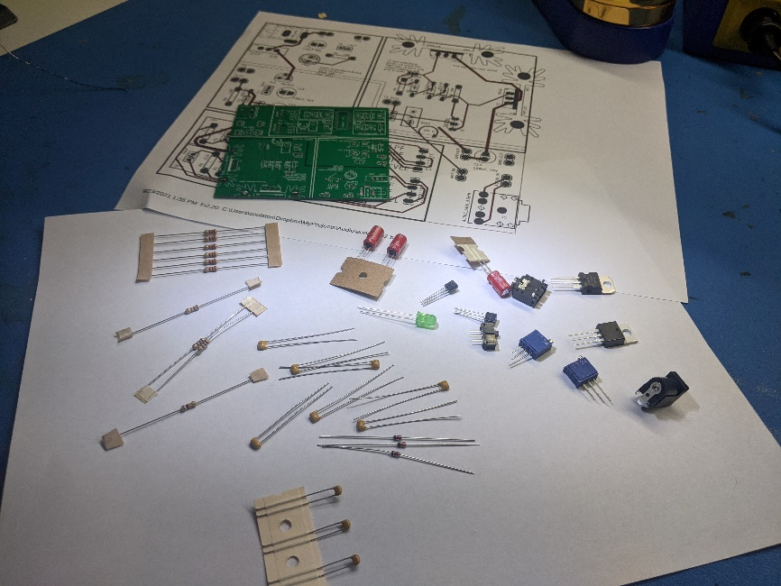

* **Select a part to install:** I would highly advise soldering in the lowest profile part first. By profile, I mean the height of the part off the board. In our case, this will be the resistors. I always install all the resistors of the same value at the same time. I use a pair of cutters to remove the resistors from the paper tape. Next, you will have to modify the shape of the leads to make installing the part in the board easier. Use a pair of needle noise pliers for this task. Bend the resistors as close to the body as possible.

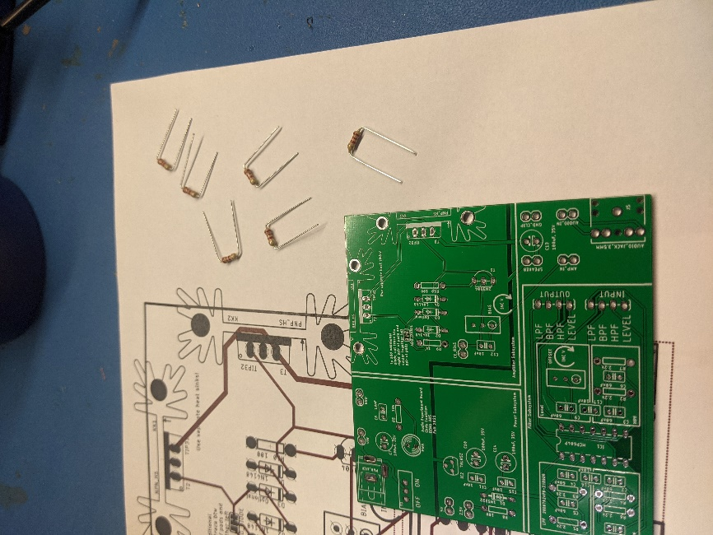

* **Stuff components:** This sounds easy, but stuffing the board is the most important step because you are going to double check that you are installing the correct component in the correct place! This means reading the color codes on the resistor and checking that it matches the parts value silk screened on the PCB (you may want a copy of Table 1on hand). Also, you should always align resistors so that their tolerance bands are on the same side - because you take pride in your work. Once inserted, flip the board over and bend the leads outward so that the resistor does not slip out of its hole during soldering.
* **Solder components:** Apply the clean soldering tip to the junction of the component lead and the PCB. Feed in a bit of solder on the iron to make a liquid ball of hot solder. Wait 1-2 second for this ball to heat the lead and the PCB. Then feed in about an 1/8” – ¼” of solder. After removing the solder, keep heating the joint for an additional 1-2 seconds. This will encourage the solder to seep well into the hole, creating a solid electrical and mechanical connection between the component lead and the PCB.
* **Trim leads:** This is the most dangerous step because when trimmed, the leads will fly away with surprising speed, creating a hazard to anyone nearby who is not wearing eye protection. Eye protection is mandatory while soldering, either safety glasses or eyeglasses. Prescription glasses are fine as we in a low-kinetic energy environment,

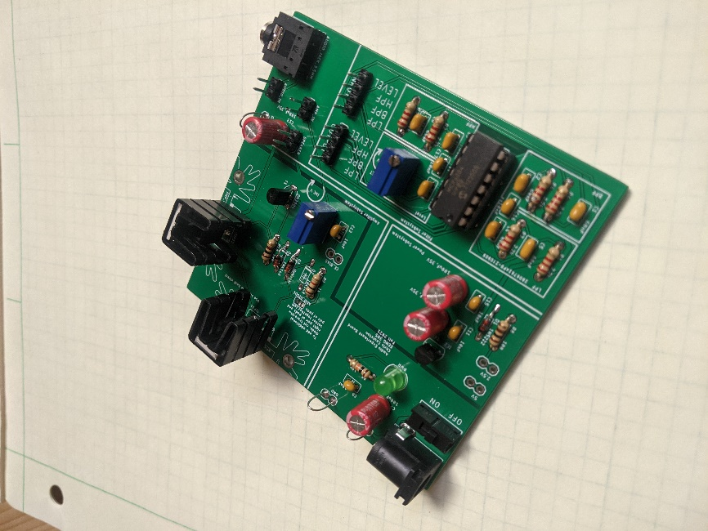

Figure 8: Completed Audio board. Note that I populated the CORRECT diode positions in this picture.

# Testing the Audio board

One you have completed assembly, perform the following checks. Please power the audio board on and off between checks. If you do not have the common emitter amplifier correctly biased, the large TO-220 BJTs will get very hot and could burn you.

**Power subsystem**

You should use a digital multimeter to make the following measurements.

* Power on LED illuminates
* 5V header is regulated to 5V +/- 0.1V
* 2.5V header is regulated to 2.5V +/- 0.1V

# Turn in:

Make a record of your response to numbered items below and turn them in a single copy as your team’s solution on Canvas using the instructions posted there. Include the names of both team members at the top of your solutions. Use complete English sentences to introduce what each of the following listed items (below) is and how it was derived.

**LM7805**

Questions 1 – 5

**Zener Diode**

Questions 1 – 3

**Power-on LED**

Questions 1 – 9

**On/off switch**

Questions 1 – 5

**Testing the Audio Board**

Complete soldering will be evaluated using soldering rubric

Operational and tested

* + Power-on LED
  + 5V
  + 2.5V